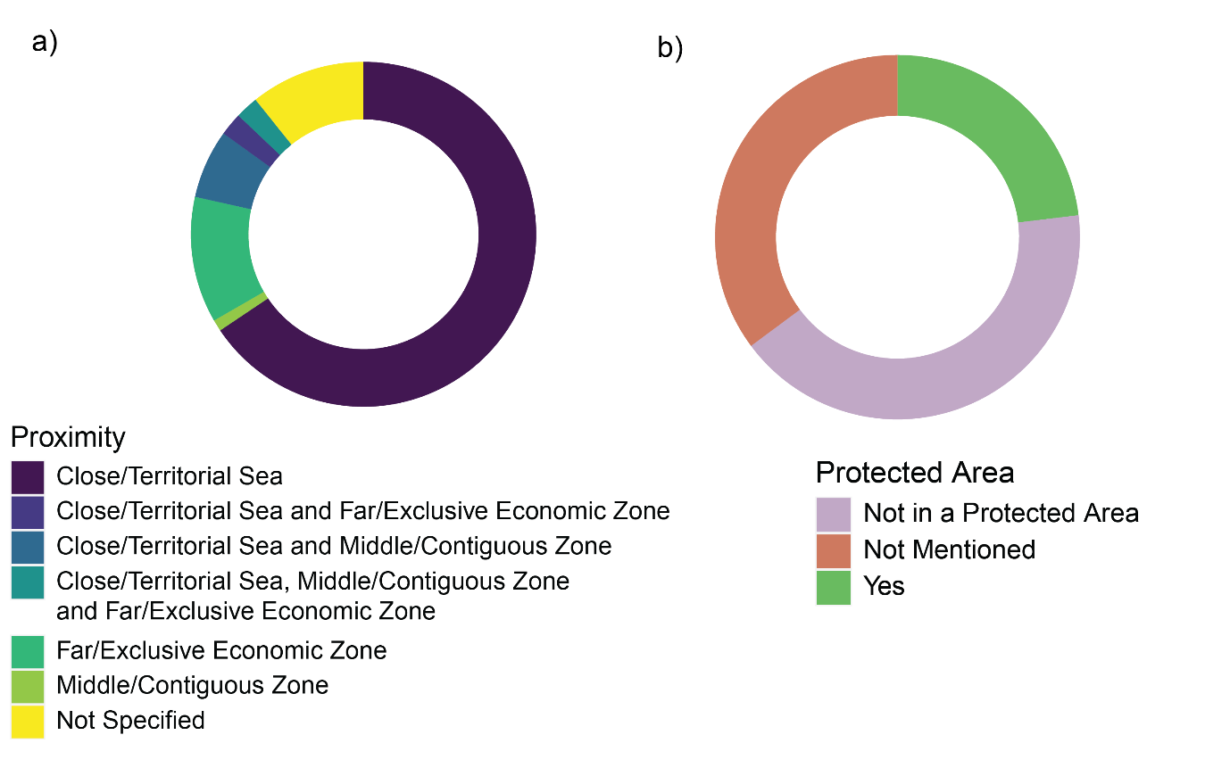

Figure 8a) Donut plot showing the proximity of the locations of studies to the closest EEZ across all literature in this systematic map, created using R package ggplot2. b) Donut plot showing the proportions of studies that took place in a protected area, created using R package ggplot2.